Executive Summary

ChoreHive solves these issues through a comprehensive system featuring Before-and-After Photo Verification, a Worker Skill Badge System, Customizable Task Checklists per booking, Rebooking Pattern Insights, and a Reports & Performance Dashboard. The platform serves three user roles: Clients who book and verify services, Staff/Workers who execute jobs and build reputations through earned badges, and Admins who manage operations, finances, and quality control.

The system targets busy professionals, families with children, elderly homeowners, and landlords. All segments that value reliability, transparency, and convenience in home maintenance. Revenue is generated through service fees per completed job and premium worker listings via featured badges. Unlike existing local cleaning platforms that offer basic scheduling without verification, ChoreHive provides end-to-end transparency that builds long-term trust and encourages repeat bookings.

Customer Validation Board
Startup Idea: | ChoreHive: Web-Based Cleaning Service Booking System
Stage:
Experiment | 1 | 2 | 3 | 4 | 5 | 6
Customer | Elderly Homeowner | Busy Professionals | Landlords | Families
Problem | Cannot verify worker skills and work quality | Difficulty finding reliable workers and rebooking | Difficulty monitoring cleaning quality across properties | Cleaning tasks may be incomplete or unaddressed
Solution
Riskiest Assumption | Problem still exists | Problem still exists | Problem still exists | Problem still exists
Success Criteria | 70% using personal interview | 70% using personal interview | 70% using personal interview | 70% using personal interview
Results & Discussions | Q8 + Q9 average = 3.00/5 | Q11 = 3.00/5 | Q8 = 3.00/5 | Q8 + Q12 average = 3.00/5
Learnings | Elderly homeowners confirmed experiencing unreliable and inconsistent cleaning service quality, often resulting in dissatisfaction and difficulty finding cleaners they can depend on. | Busy professionals confirmed facing concerns about cleaner reliability and poor work quality, often encountering incomplete or inconsistent results when hiring cleaning services. | Landlords confirmed having difficulties maintaining consistent cleaning quality across multiple properties, making it hard to ensure that their spaces are properly cleaned between tenants. | Families confirmed experiencing poor or unreliable cleaning output, often feeling uncertain whether the service they paid for actually met the standard they expected.
Stage 1 (Problem Validation)

Figure 1.1: Customer Validation Board of ChoreHive: Web-Based Booking System for Cleaning Services

Stage 2 (Pitch using Landing Page)
Startup Idea: | ChoreHive: Web-Based Cleaning Service Booking System
Stage:2
Experiment | 1 | 2 | 3 | 4 | 5 | 6
Customer | Elderly Homeowner | Busy Professionals | Landlords | Families
Problem | Cannot verify worker skills and work quality | Difficulty finding reliable workers and rebooking | Difficulty monitoring cleaning quality across properties | Cleaning tasks may be incomplete or unaddressed
Solution | Reliable cleaner with verified quality | Verified and reliable cleaning service | Reliable cleaner verification and quality monitoring | Verified cleaning service with task monitoring
Riskiest Assumption | Problem still exists | Problem still exists | Problem still exists | Problem still exists
Success Criteria | 70% using personal interview | 70% using personal interview | 70% using personal interview | 70% using personal interview
Results & Discussions | 4/5 = Agree | 3/5 = Neutral | 4/5 = Agree | 4/5 = Agree
Learnings | Elderly homeowners may experience problems with expensive or unreliable cleaning services and need a more trustworthy way to hire cleaners. | Busy professionals experience concerns regarding cleaner reliability, errors, and misleading information, indicating a need for a more dependable cleaning platform. | Landlords need dependable cleaners and consistent service quality, particularly when managing multiple rental properties. | Families value reliable cleaning results and want assurance that the service is worth the fee.

Figure 1.2: Customer Validation Board of ChoreHive: Web-Based Booking System for Cleaning Services

STARTUP DESCRIPTION
Startup Project Name
ChoreHive: Web-Based Cleaning Service Booking System
Synergy
Information Technology and Home Services

Product Type
Materials
- Computer or laptop for development and deployment
- Smartphone or tablet for mobile access by clients and workers
- Stable internet connection (PLDT, Globe Fiber, Converge, MarbelTel, etc.)
- Web server for hosting the platform
Software
- Windows Operating System
- Web browser (Chrome, Firefox, Edge)
- Code editor (VS Code or similar)
- Database management system
- 000webhost

STARTUP STAGE

Phase 1: Idea Generation and Research
Research and Development: ChoreHive was developed to address common problems in low-quality work and unverified worker skills and backgrounds by cleaning services that focus on cleaner verification, task control, service transparency, and convenient booking.

Market Research: The survey targeted busy professionals, families, elderly homeowners, and landlords to identify their experiences and concerns when hiring cleaning services.
Concept Development: The concept combines online cleaning-service booking with customized task checklists, worker skill badges, before-and-after photo verification, and convenient rebooking.

Competitor Analysis: The project examined existing cleaning-service options and identified opportunities to provide stronger service transparency, worker verification, and customer control.

Idea Validation: The survey identified several customer concerns related to worker skills/backgrounds, service quality, and rebooking. The strongest concern was worker skills/backgrounds, which received an average rating of 3.75/4 on the 4-point scale. Overall, the seven problem questions had an average rating of 2.50/4, while all four respondents indicated that they would try ChoreHive.

Phase 2: Planning and Development
Business Plan Creation: The Business Model Canvas was develop to define ChoreHive's customer segments, key partners, activities, resources, costs, channels, and revenue streams.

MVP/Prototype Development: A web-based prototype has been plan around customer booking, customized checklists, worker selection, photo verification, payment verification, feedback, and rebooking functions.

Team Building and Role Assignment: The system is organize around Admin, Staff/Worker, and Client roles, with each role assigned specific functions for managing services, bookings, workers, and customer activities.

Budget and Resource Planning: Resources are plan around web hosting and maintenance, cleaning supplies and tools, worker recruitment and salaries, and other operational requirements.
Goal and KPI Setting: The project aims to improve booking convenience, service transparency, customer satisfaction, worker performance, and repeat bookings through system records and performance reports.

Phase 3: Testing and Iteration

Usability Test
The prototype will be tested with users from the identified customer segments to evaluate the booking process, checklist creation, photo verification, and rebooking functions.

User Feedback Collection
Feedback will be gathered through questionnaires and user observations to determine whether the system's features address the customers' actual concerns.

Feature Iteration
Development will prioritize Photo Verification, Worker Skill Badges, and Custom Task Checklists, which each received an average usefulness rating of 3.25/4 in the survey.

Phase 4: Product Launch and User Acquisition

Feedback and Improvement
Survey and testing results will be used to improve ChoreHive's usability, reliability, verification process, and customer experience before wider implementation.

Marketing and Sales
ChoreHive will use social media and word-of-mouth to attract customers and workers, while generating revenue through service fees and premium worker listings.

Phase 5: Scaling and Expansion

Operations Optimization
Booking history, worker performance, customer feedback, and reports will be used to improve service operations and identify areas that need attention.

User Base Growth
ChoreHive will build its customer and worker base by encouraging repeat booking and recommendations, supported by the survey result that all four respondents said they would try the system; willingness to recommend it was not measured and will be asked in the next survey round.

Funding and Investment
The system can seek additional funding or investment to support platform maintenance, worker recruitment, marketing, and future expansion.

Market Expansion
After establishing the service in its initial target area, ChoreHive can expand to additional communities and service areas.

Infrastructure and Team Scaling:
As the number of users and bookings increases, the platform's technical infrastructure and staff or worker network can be expanded to maintain service quality.

Product/Service Description
ChoreHive is a web-based booking system designed to make cleaning services more reliable, transparent, and convenient for customers. It allows users to browse available services, create customized task checklists, select preferred workers, monitor job progress through before-and-after photos, verify completed work, provide feedback, and rebook trusted cleaners. Workers can showcase their skills through badges and manage assigned jobs, while administrators and staff can manage users, services, bookings, payments, reports, and worker performance. The system was designed based on survey findings showing that customers are particularly concerned about cleaner skills/backgrounds and service reliability.

The Problem
- ‎Customers who book house cleaning cannot verify if work was actually completed properly when they are not home, leading to disputes and low trust.

- ‎Fixed service packages force customers to accept a generic set of tasks, causing miscommunication about what should be done and leaving some tasks unaddressed.

- ‎Customers have no reliable way to judge a worker's real skill level making it hard to pick the right person for specialized chores.

- Customers who need recurring chores must manually re-book and retype the same details every time, wasting time and effort.

- Management has no consolidated data on revenue, demand, and worker output, making business decisions harder to base on facts.

Customer Segments
- Administrators
- Staff / Workers
- Busy Professionals
- Families
- Elderly Homeowners
- Landlords

Competitive Advantage

ChoreHive's main competitive advantage is its focus on trust, transparency, and customer control. Unlike a basic booking platform, the system combines worker skill badges, customized task checklists, and before-and-after photo verification to give customers more information and control over the cleaning service they receive. This directly responds to the survey finding that 50% of respondents considered not knowing a cleaner's skills or background their biggest frustration, while Photo Verification was the most preferred feature at 50%.
Another advantage is the system's ability to support the entire cleaning-service process in one platform, including service browsing, booking, worker selection, task-completion, photo verification, payment verification, feedback, and rebooking. ChoreHive also provides workers with badges and achievement tracking while giving administrators tools for managing workers, bookings, reports, and financial information. This creates a more organized service experience for both customers and workers and provides a foundation for future growth.

Revenue Streams

- Service Fees per Completed Job
- Premium Worker Listings
.

Team Description
PICTURE
PICTURE
PICTURE
PICTURE
PICTURE

ROLE | ROLE | ROLE | ROLE
NAME | NAME | NAME | NAME
DESCRIPTION | DESCRIPTION | DESCRIPTION | DESCRIPTION

Table 1.1: Team Description

STARTUP CHALLENGES
Product Definition
ChoreHive is a web-based booking system designed to connect customers with cleaning service workers while making the booking process more reliable and transparent. The system provides features such as customized task checklists, worker skill badges, before-and-after photo verification, worker selection, payment verification, feedback, and rebooking. These features were designed around the needs of busy professionals, families, elderly homeowners, and landlords identified in the customer validation process.

Problem and Solution
The main challenges identified through the survey were concerns about cleaner skills and backgrounds, poor or incomplete cleaning work, overpaying for services that do not meet expectations, difficulty rebooking trusted cleaners, and the lack of a reliable way to verify completed tasks. Among these concerns, 50% of respondents identified not knowing the cleaner's skills or background as their biggest frustration. ChoreHive addresses these problems through worker skill badges, customized task checklists, before-and-after photo verification, job verification, and convenient rebooking.

Conclusion
The survey identified key customer concerns rather than a 75%–80% problem-validation rate. The strongest concern was not knowing a cleaner's skills or background, which received an average rating of 3.75/4 on the 4-point scale and was the only concern agreed with by every respondent. Overall, the seven problem questions had an average rating of 2.50/4. In addition, all four respondents indicated that they would try ChoreHive; willingness to recommend was not measured. With only four respondents, these findings are indicative and support prioritizing trust and service-verification features while continuing to validate the problems with a larger sample and improve the system through user feedback.

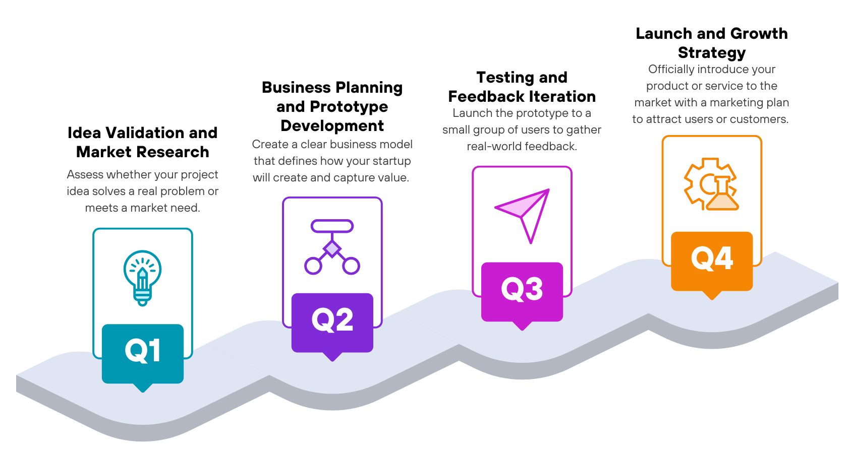
ROADMAP

Figure 1.3:

Figure 1.3: Roadmap of ChoreHive: Web-Based Booking System
for Cleaning Services

Idea Validation and Market Research
- ChoreHive was developed to address common problems experienced by busy professionals, families, elderly homeowners, and landlords when hiring cleaning services. The survey identified several concerns, with the strongest concern being the lack of information about a cleaner's skills and background. This was rated 3.75/4 on average and was also identified by 50% of respondents as their biggest frustration. These findings support the need for a more reliable, trustworthy, and transparent way to hire and manage cleaning services.

Business Planning and Prototype Development
- Based on the survey findings, the team developed ChoreHive's business model and prototype around features that directly address customer needs. The survey showed that Before-and-After Photo Verification, Worker Skill Badges, and Custom Task Checklists were the most useful features, each receiving an average rating of 3.25 out of 4. These results guided the development of the system's core booking, worker verification, customized checklist, photo verification, and rebooking functions to provide customers with greater control and confidence when using the service.

Testing and Feedback Iteration
- The ChoreHive prototype will be tested with users representing the identified customer segments to evaluate the system's usability and the usefulness of its main features. The survey results showed that Photo Verification was the most preferred feature, selected by 50% of respondents, making it an important feature to prioritize during testing. Feedback will be used to improve the booking process, verification flow, checklist functions, and overall user experience. Smart Suggestions may receive less priority during early iterations because 100% of respondents identified it as the least important feature.

Launch and Growth Strategy
- ChoreHive will be introduced initially to its target customers through social media and word-of-mouth promotion, focusing on building trust and attracting early users. The survey results show promising acceptance, with all four respondents indicating that they would try ChoreHive. The launch will therefore prioritize the features customers value most, particularly Photo Verification, Worker Skill Badges, and Custom Task Checklists. As the platform grows, customer feedback and booking data can be used to improve services, encourage repeat bookings, and expand ChoreHive to additional users and service areas.

Purpose
The purpose of ChoreHive: A Web-Based Booking System for Cleaning Services is to provide customers with a more reliable, transparent, and convenient way to book and manage cleaning services. The system addresses concerns identified in the survey, particularly customers uncertainty about a cleaner's skills and background, poor or incomplete work, and difficulty ensuring that requested tasks were completed.

ChoreHive allows customers to browse services, create a customized task checklist, select a preferred worker, monitor completed tasks through before-and-after photos, verify the job, provide feedback, and rebook trusted workers.
The system also aims to help cleaning workers showcase their skills through badges and track their achievements, while administrators and staff can manage workers, bookings, services, reports, compensation, and system operations.

Advantages
- Improves Customer Trust
- Provides Proof of Completed Work
- Allows Customized Cleaning Tasks
- Makes Rebooking Easier
- Provides Better Job Transparency
- Supports Worker Recognition
- Centralizes Cleaning-Service Management

Disadvantages
- Requires Internet Access
Because ChoreHive is a web-based booking system, customers, staff, and workers need internet access to use its online functions effectively.

- Depends on Accurate Worker Information
The effectiveness of the Worker Skill Badge System depends on the accuracy of worker profiles, achievements, and badge information. Incorrect or outdated information could reduce customer trust.

- Photo Verification Requires Worker Compliance
The Before-and-After Photo Verification feature depends on workers uploading the required photos. If photos are missing, unclear, or not uploaded properly, customers may have difficulty verifying the completed work.

- Requires Proper System and Data Management
ChoreHive handles customer profiles, worker information, bookings, payments, feedback, and performance records. These functions require proper maintenance and administration to keep the system reliable.

- May Require Training for New Users
Customers, workers, staff, and administrators may need some time to become familiar with the booking, checklist, photo verification, payment, and management features.

- Smart Suggestions May Have Limited Value
The survey showed that 100% of respondents selected Smart Suggestions as the least important feature. This means the feature may provide less immediate value compared with Photo Verification, Skill Badges, and Custom Checklists.

Investment Capital Distribution
The investment of ₱50,000 will be allocated to the important activities and resources needed to develop and launch ChoreHive: A Web-Based Cleaning Service Booking System. The budget will support system development, contractor and team expenses, hosting and photo storage, worker recruitment and badge setup, promotion, and unexpected costs. This distribution aims to provide enough resources for the development, testing, deployment, and initial operation of the system.
Category | Percent | Amount (₱) | What it covers
Core System Development | 35% | ₱17,500 | PHP/MySQL development of booking, custom task checklists, before-and-after photo verification, rebooking insights, testing, and debugging.
Salaries / Contractor Fees | 20% | ₱10,000 | Developer or QA contractor support for the admin dashboard, reports, and worker and booking management.
Hosting, Database & Photo Storage | 15% | ₱7,500 | Web hosting, domain, SSL, database, backups, and storage for the before-and-after photos uploaded with every booking.
Worker Recruitment & Badge Setup | 10% | ₱5,000 | Recruiting the first workers, verifying their skills, and setting up the Worker Skill Badge criteria.
Advertisement & Promotion | 10% | ₱5,000 | Social media promotion, posters, word-of-mouth campaigns, and the system introduction to the four customer segments.
Reserve / Petty Cash | 10% | ₱5,000 | Unexpected expenses such as additional testing, bug fixes, or verification disputes.
Total | 100% | ₱50,000 | Full allocation of seed capital.

Table 1.2: Investment Capital Distribution of ChoreHive: Web-Based Booking System for Cleaning Services

Business Model Canvas
Business Model Canvas ChoreHive: Web-Based Booking System for Cleaning Services

Key Partners  000webhost  Trained/Experienced  Workers  Online Payment  Providers  Cleaning Supply  Distributors  PLDT, MarbelTel, Converge, Globe Fiber, etc. | Key Activities  Manage Badge  Before and After Photo  Staff Assigned and Dispatch  Booking Management | Value Proposition  Auto-generated performance report  Rebooking Pattern  Insights  Worker Skill Badge  Customized Task Checklist per Booking  Before and After Photo Verification |  | Customer Relationship  Automated Services Ensure Job Transparency | Customer Segments  Busy professionals, families, elderly homeowners, and landlords  Staff/Worker  Admin
 | Key Resources  Pool of Skilled and  Badge Workers  Web-based Booking Platform |  |  | Channels  Word of Mouth  Social Media
Cost Structure  Cleaning Supply and Tools  Web Hosting and System  Maintenance  Worker Recruitment and Salary |  |  | Revenue Streams  Premium Worker Listing  (Featured Badge)  Service Fees per Completed  Job

Figure 1.4: Business Model Canvas of ChoreHive: Web-Based Booking System
for Cleaning Services

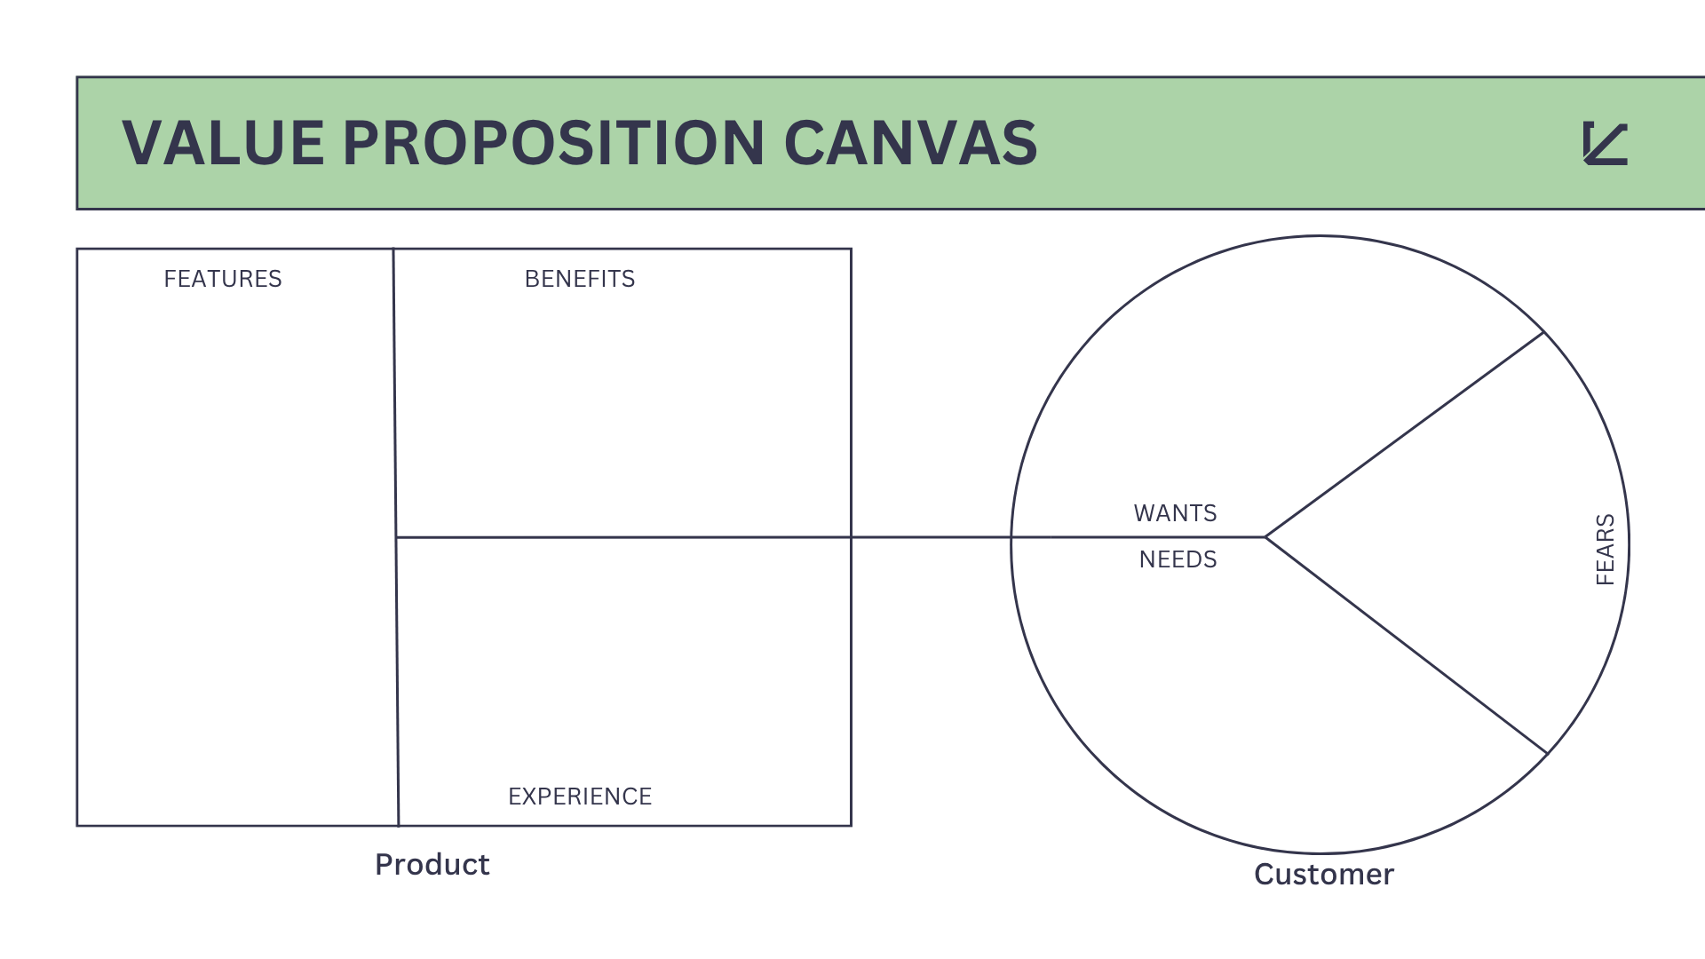
Value Proposition Canvas

Fast rebooking system
Proof of completed work
Same trusted workers
Verified home workers
Control over chore list
One-tap rebooking
Revenue & performance view
Accurate auto-billing
Badges show skill level
Photo proof before payment
Before and After Photo Verification
Customized Task Checklist per Booking

Worker Skill Badge
Rebooking Pattern
Insights

Hard to change schedule
Overpaying for bad service
Poor/incomplete work
No proof of work done
Unauthorized Visitor
Figure 1.5

Personalized stress-free booking
Badge-based trust
Effortless repeat booking
Full job transparency
Proof always on record
No supervision needed
Booking history tracker
Consistent quality always
Clear upfront pricing
Recurring chore schedule
Rebooking Pattern
Insights

Figure 1.5: Value Proposition Canvas of ChoreHive: Web-Based Booking System
for Cleaning Services

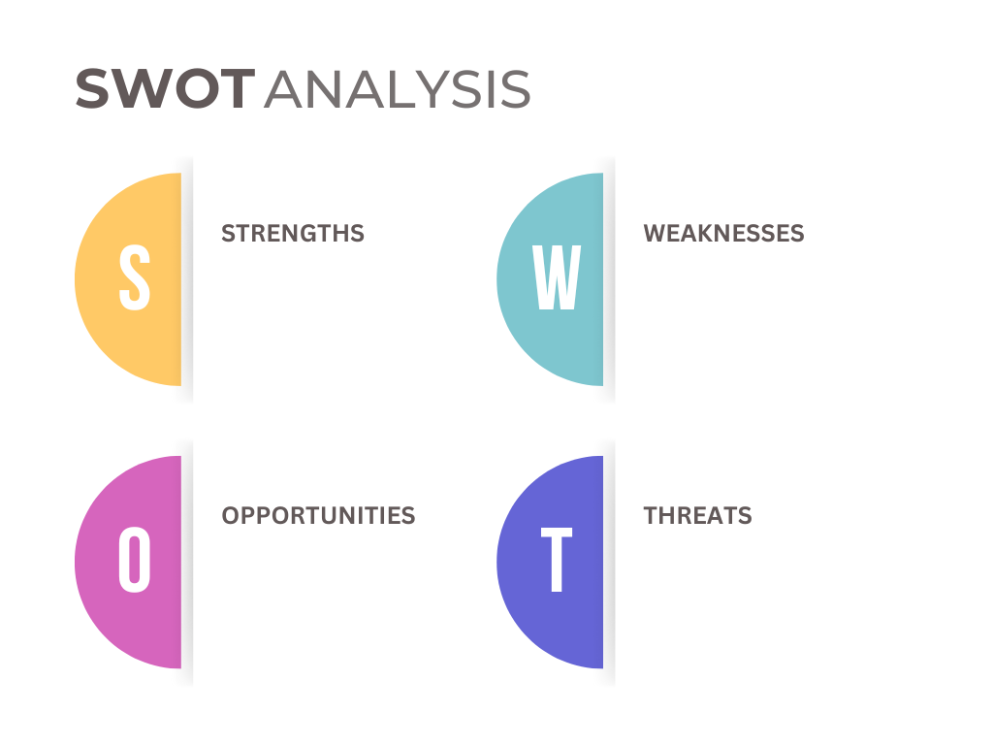
SWOT Analysis

- Requires Internet Connection
- Worker Upload Dependency
- User Learning Required
- Continuous System Maintenance
- Limited Feature Priority

- Photo Verification System
- Worker Skill Badges
- Customized Task Checklist
- Easy Worker Rebooking
- Customer Service Transparency

- Existing Service Competition
- Customer Trust Concerns
- Poor Worker Performance
- Technical System Issues
- Low Feature Adoption

- Expanding Customer Base
- Wider Service Areas
- Social Media Promotion
- Cleaning Industry Partnerships
- Performance Data Analysis

Figure 1.6: SWOT Analysis of ChoreHive: Web-Based Booking System
for Cleaning Services

Technology Stack
Product Materials

Figure 1.7: Technology Stack of ChoreHive: Web-Based Booking System
for Cleaning Services

Windows Operating System
Main platform used for developing, testing, and deploying the ChoreHive web-based system.

PHP (Hypertext Preprocessor)
Server-side scripting language used to handle the backend logic of ChoreHive, including processing bookings, managing user accounts, and handling database operations.

XAMPP Server Database
Local development environment used to run and test the ChoreHive system on a local machine before deployment, providing Apache server and MySQL database support.

HTML (Hypertext Markup Language)
Used to create the structure of the ChoreHive web-based booking system, including service listings, booking forms, user profiles, task checklists, and dashboards.

CSS (Cascading Style Sheet)
Used to design and style the ChoreHive website, ensuring an organized, user-friendly, and responsive interface for clients, staff, and administrators.

JavaScript
Used to add interactivity and dynamic features to ChoreHive, such as form validation, booking updates, checklist interactions, and real-time user interface responses.

Functional Decomposition Diagram

Figure 1.8: Functional Decomposition Diagram of ChoreHive: Web-Based Booking System for Cleaning Services

Flow of the Study

Input Process Output

- Storing customer and booking records

- Processing and saving checklist per job

- Storing photos to the specific booking

- Processing badge eligibility based on job performance

- Analyzing re-booking patterns and detecting repeated schedules

- Customer registration and booking details

- Custom task checklist per booking

- Before and after photo uploaded by worker

- Staff profile, skills, and job records

- Booking history and frequent data per customer

- Display of registered customer accounts and booking history

- Display assigned checklist to staff and client

- Display photos for customer review

- Display earned skill badges on worker profile

- Display rebooking suggestions and checklist with preferred worker

Figure 1.9: Flow of the Study of ChoreHive: Web-Based Booking System
for Cleaning Services

Storyboard

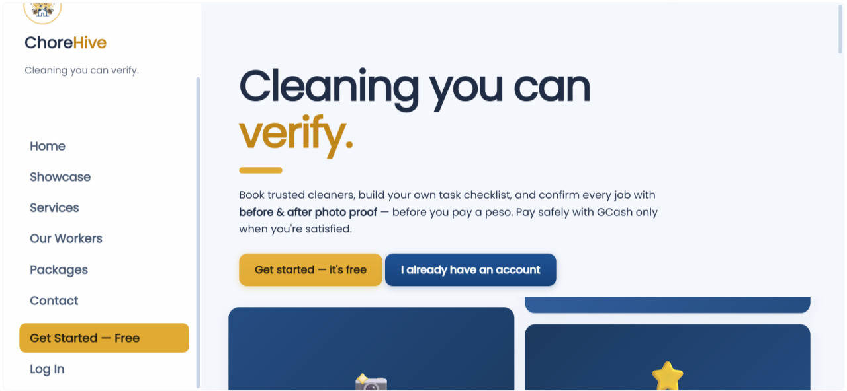

Figure 3.7.0: ChoreHive: Web-Based Cleaning Service Booking System Login Dashboard

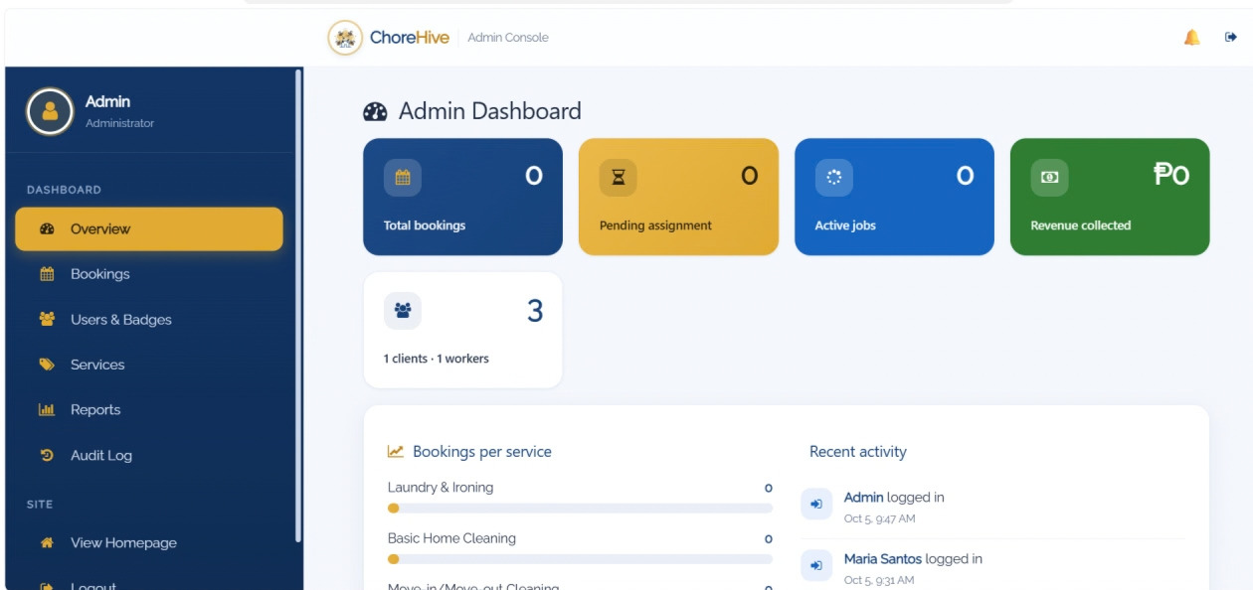

Figure 3.7.1: ChoreHive: Web-Based Cleaning Service Booking System Admin Dashboard

Summary and Conclusion

Summary
ChoreHive is a web-based booking system built to address trust, transparency, service-quality, and rebooking concerns when hiring cleaning service workers. The system features five core functions: Before-and-After Photo Verification, Customizable Task Checklist per Booking, Worker Skill Badge System, Rebooking Pattern Insights, and Auto-generated Performance Report. It serves three user roles: Admin, Staff/Worker, and Client. The customer validation survey identified worker skills/backgrounds as the strongest concern, with an average rating of 3.75/4 and 50% of respondents selecting it as their biggest frustration.

Conclusion
ChoreHive is supported by survey findings that identified customer concerns about worker skills/backgrounds, service quality, and rebooking. The survey showed all four respondents willing to try the platform; willingness to recommend was not measured. Photo Verification, Worker Skill Badges, and Custom Task Checklists each received an average usefulness rating of 3.25/4 and will be prioritized throughout development and testing. Continuous improvement will be guided by user feedback and system data.

